**Creating New CICD Pipeline**

**View and manage your pipelines**

You can view and manage your pipelines by choosing Pipelines from the left-hand menu to go to the pipelines landing page

* Click on to the create

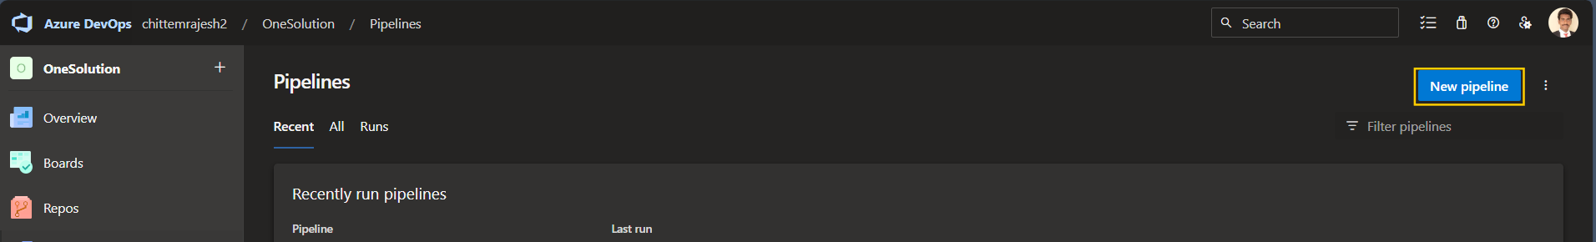

* Select the Azure repository

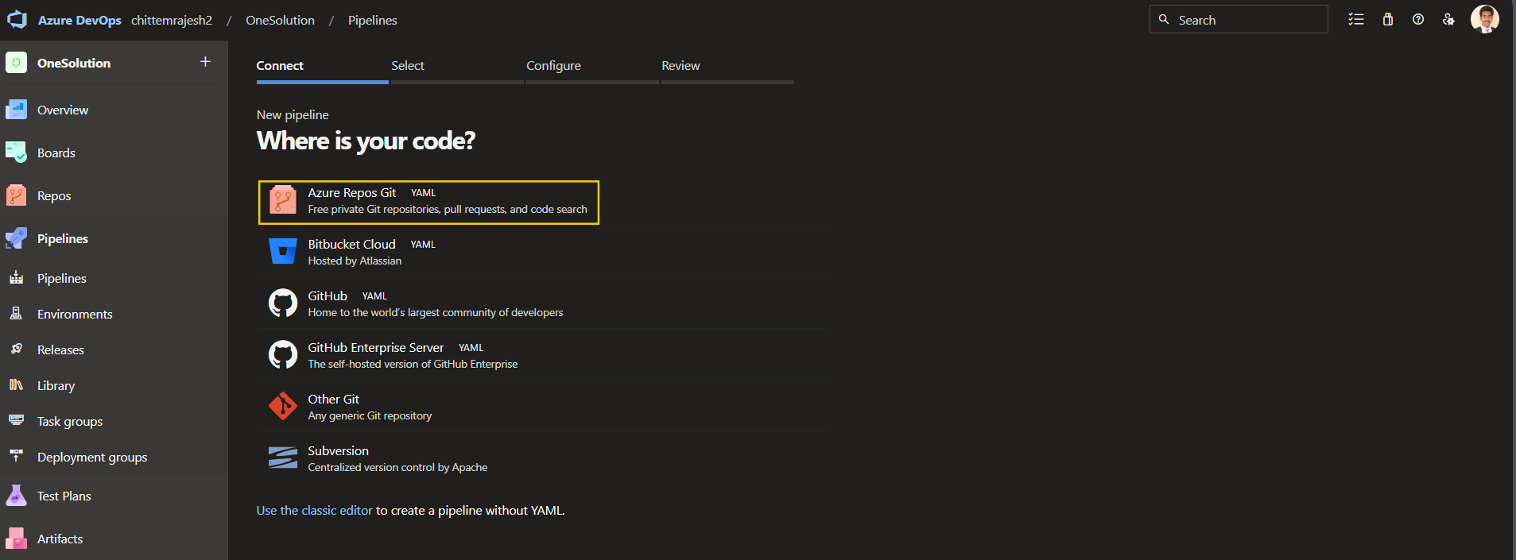

* Select the repository

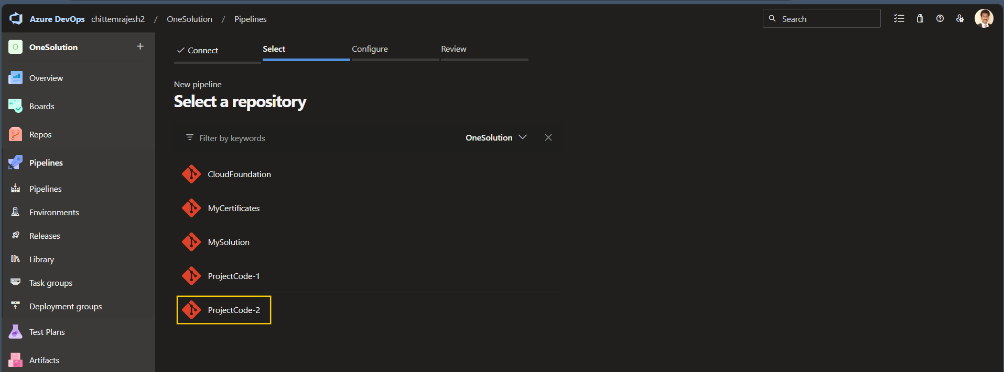

* Select Existing Azure pipeline YAML file

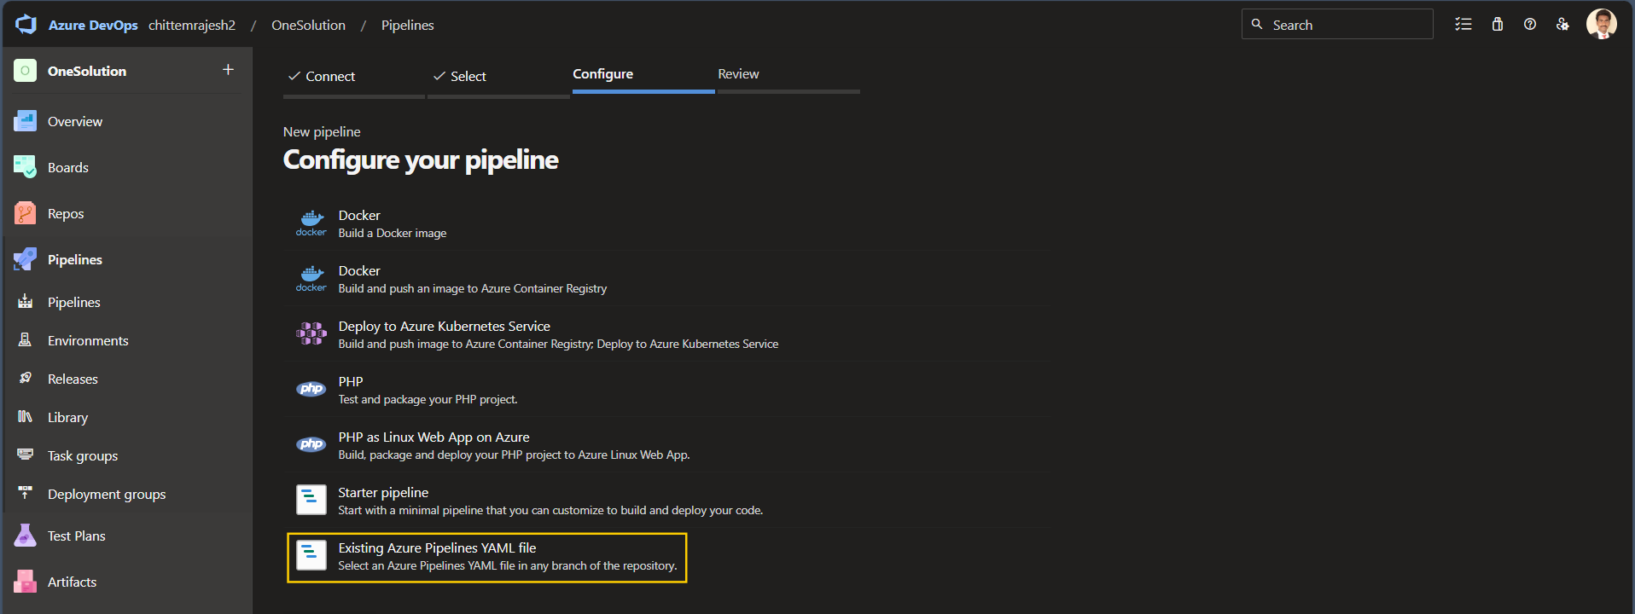

* Select yaml file

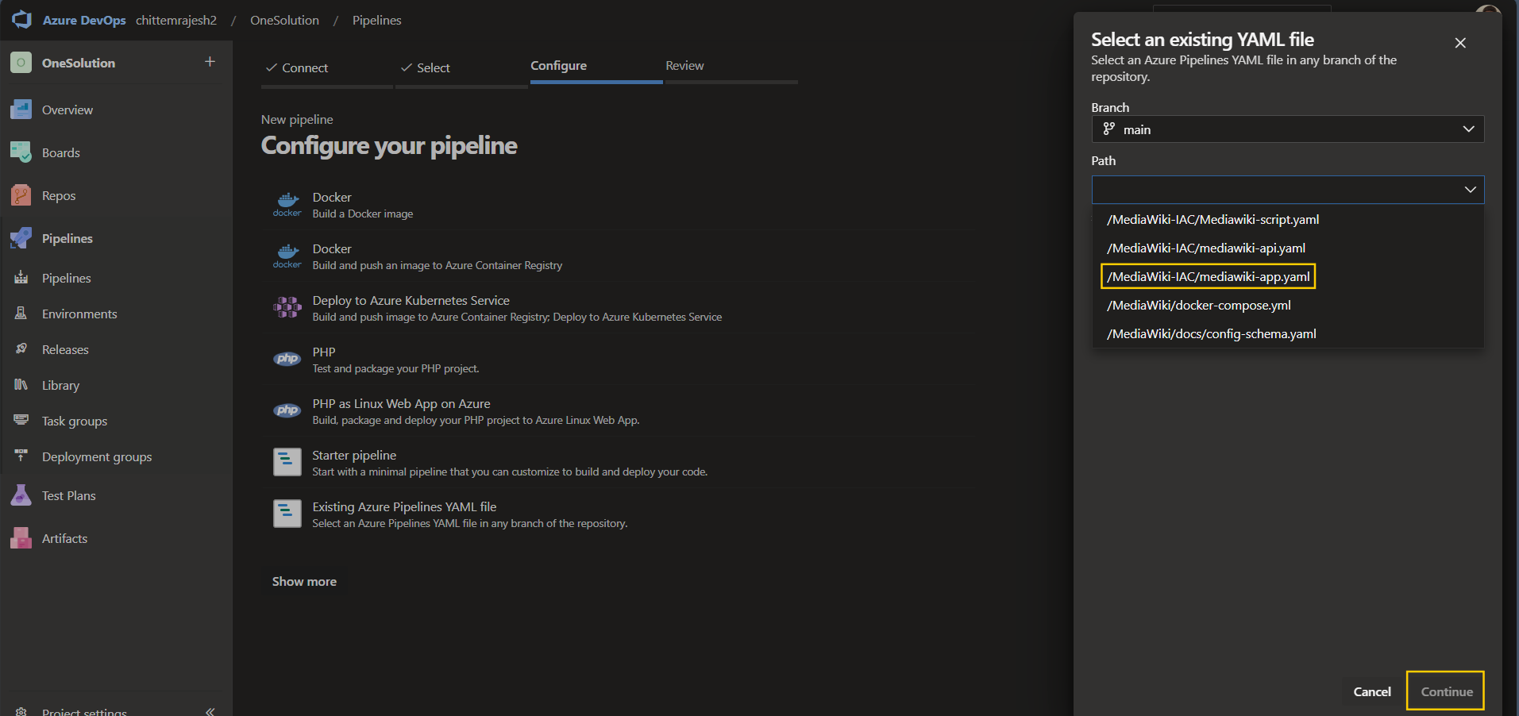

* And continue

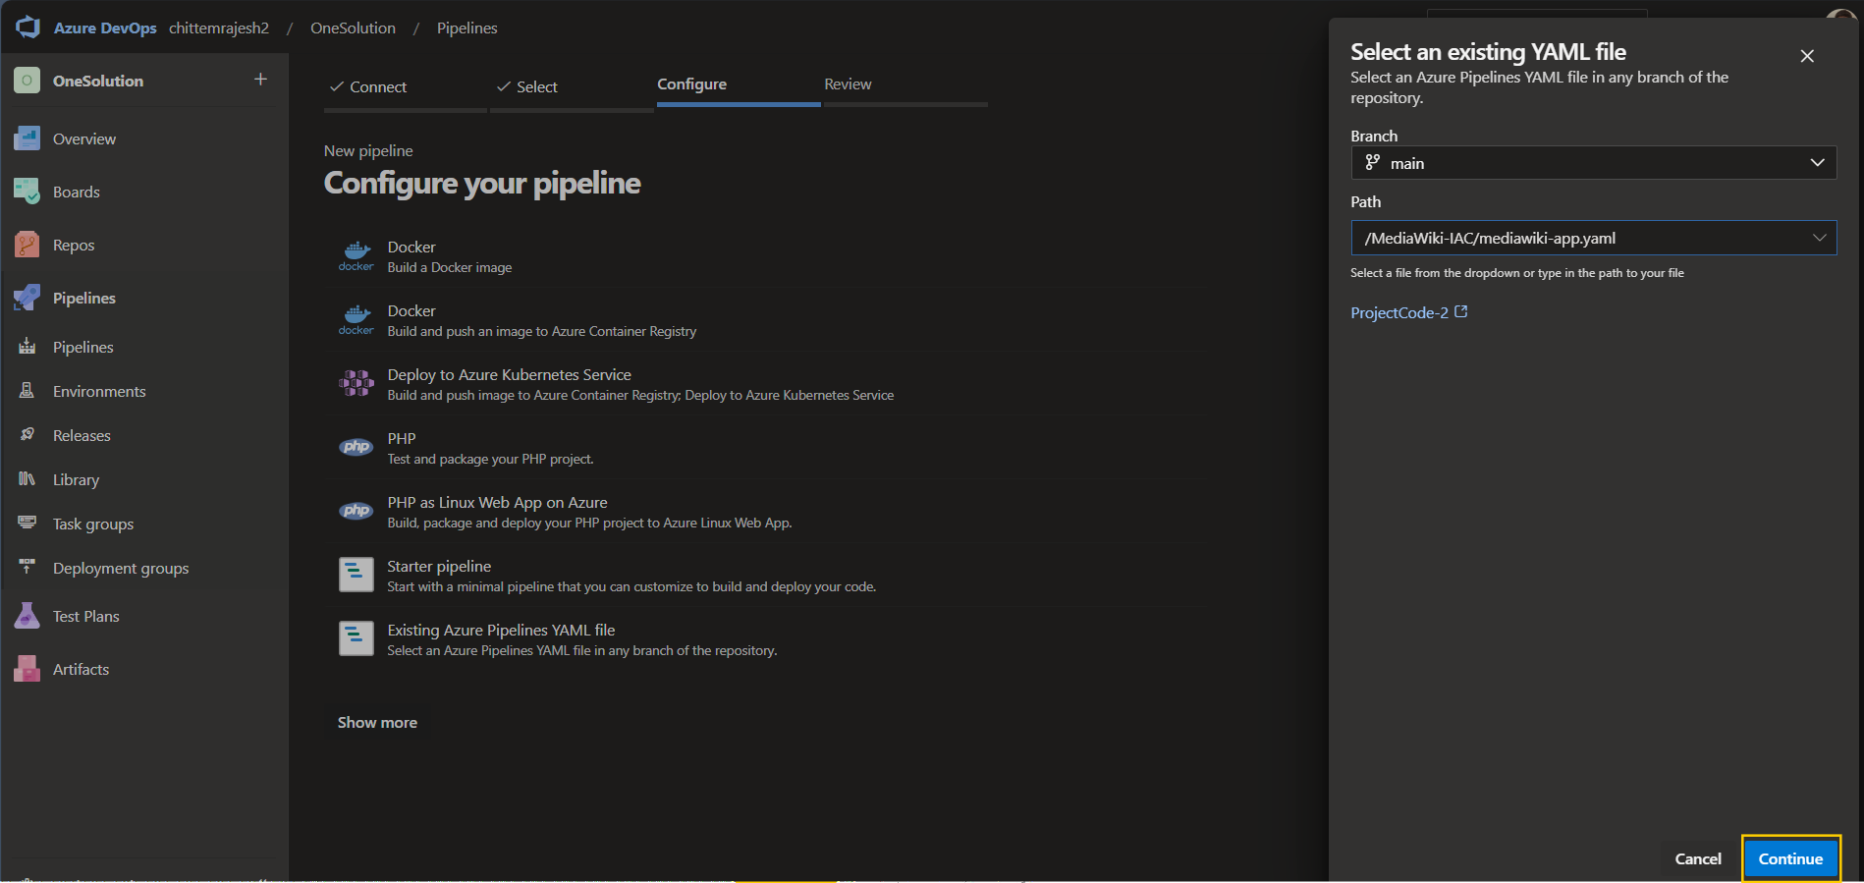

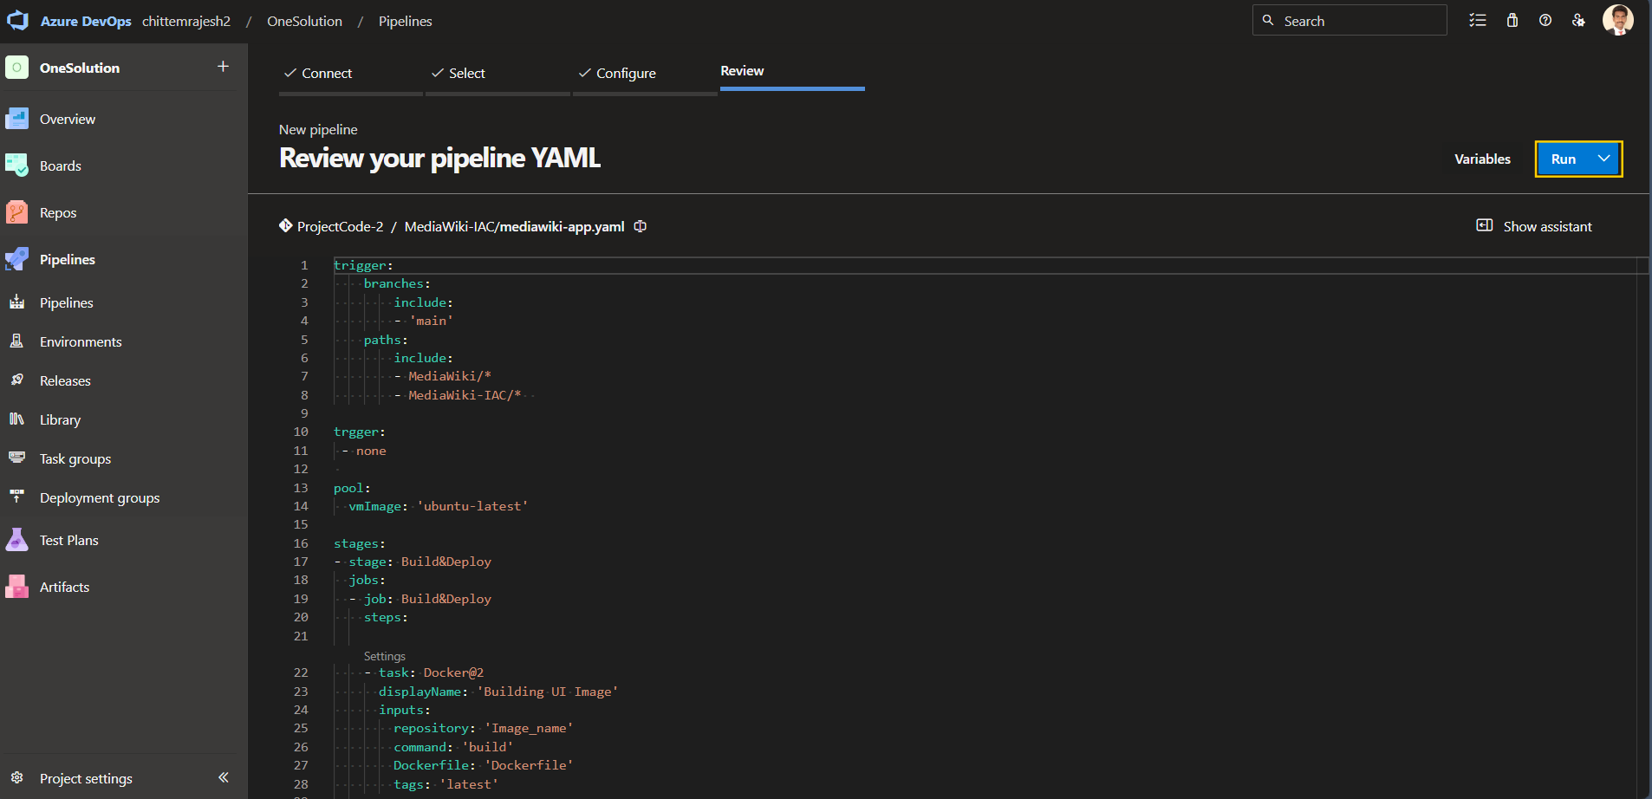

* If the code is ready and run or save the pipeline

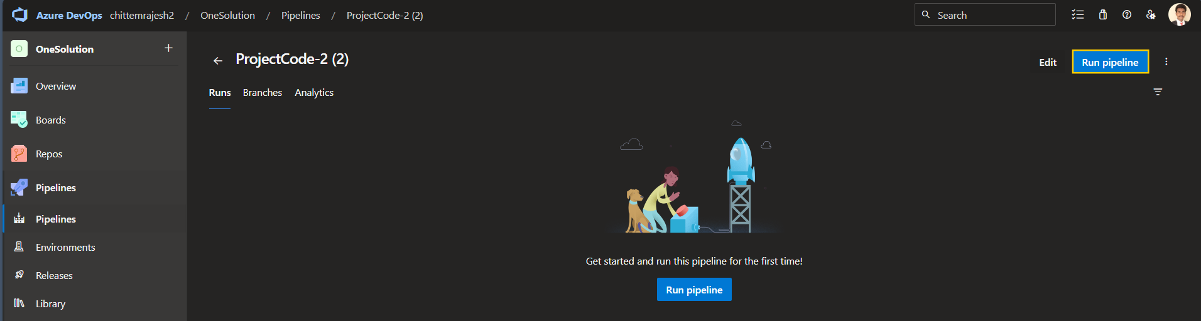

* Right top click 3 dot’s icon and click on to rename or remove option

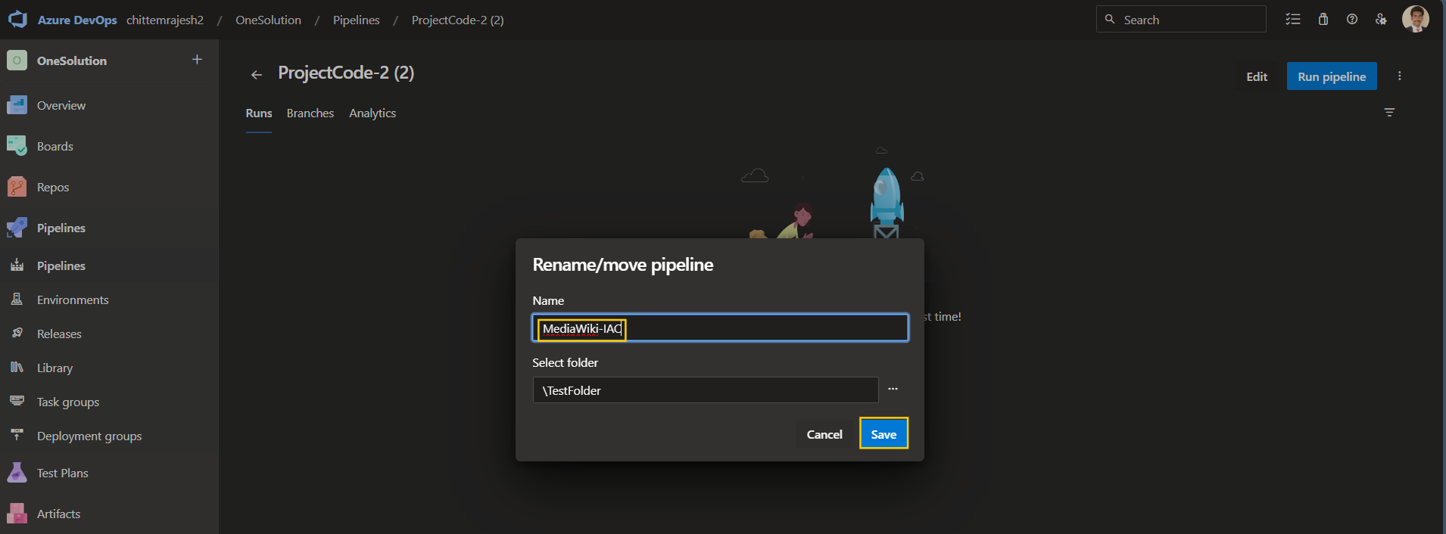

* And Save it and the run the pipeline

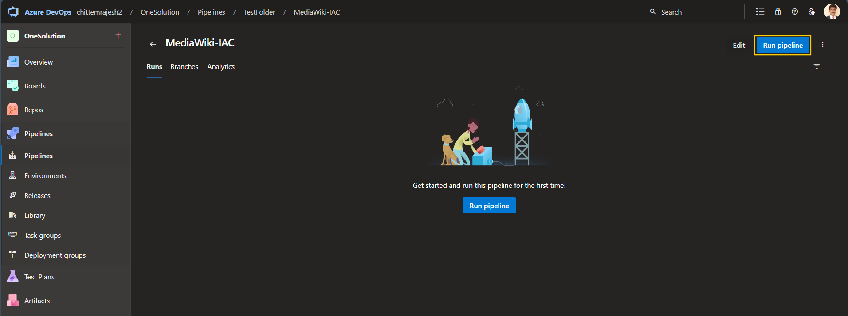

* This pipeline same for the mediawiki-api.yaml and mediawiki-script.yaml

As of know I am not running the pipeline, due to azure resource’s are not found

These are the 3 main resources required:

1. Service connection
2. Subscription name and id
3. Resource group